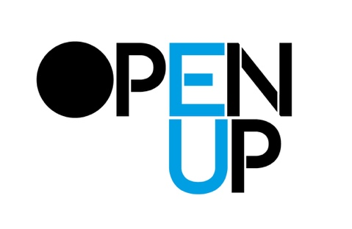
NAME___________________

Worksheet:
So you want to publish something ?

We could start by asking what you want to publish… but let us start with “why?”

Why do you want to publish?

- To share my ideas and perspectives with other people
- If “yes” : What other people?

- To get my art / poetry / stories / voice / images out there
- If “yes” : Out where, for who to see, hear, read, know?

- To be part of a wider conversation or scene
- If “yes” : What conversation(s) ? What scene(s)?

- To expand on existing or make new relationships and connections?
- If “yes” : what kinds of relationship? Connections?

- Some other reason?
- If “yes” : What other reason(s)?

What kinds of material do you want to publish?

- My work and ideas
- My friends’ work and ideas
- My colleagues’ work and ideas
- The work and ideas that I think are important
- Work and ideas that I don’t know yet, but want to find through publishing
Expand….

Some different frameworks of art publishing: Which interest you?

- Self-publishing
- Small-scale independent publishing
- Academic (art) publishing
- Museum and other institutional publishing
- Not-for-profit (NGO) publishing
- Commercial publishing
- Making a publishing infrastructure: Setting up a publishing workshop to support several publishing activities
Expand….

Some different genres of art publishing: What kinds mught interest you?

- An exhibition catalogue or project-related book
- A zine
- An artist’s book
- An experimental book
- A graphic novel
- A graphic anthology
- A picture book
- A career survey
- A collected writings
- A poetry book / “chap book” *
- A foto book
- A guide to the practice of an artist or group of artists
- A manifesto
- An anthology of critical texts
- A survey of practices or ideas
- An art journal or magazine or cultural journal or magazine
- A blog
- A vlog
- A webpage / site
- A discussion board or forum
- An imprint**

*A chapbook is a small publication of up to about 40 pages, sometimes bound with a saddle stitch. In early modern Europe a chapbook was a type of printed street literature. Produced cheaply, chapbooks were commonly small, paper-covered booklets, usually printed on a single sheet folded into books of 8, 12, 16 and 24 pages. They were often illustrated with crude woodcuts, which sometimes bore no relation to the text (much like today's stock photos), and were often read aloud to an audience. When illustrations were included in chapbooks, they were considered popular prints. (wikipedia)

** An imprint of a publisher is a trade name under which it publishes a work. A single publishing company may have multiple imprints, often using the different names as brands to market works to various demographic consumer segments. (wikipedia)
see also https://www.thebookdesigner.com/publishing-imprint/

Expand….

