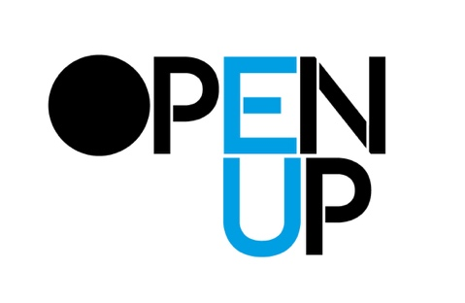
NAME ___________________

WHICH OPEN UP GROUP YOU ARE ATTACHED TO:
Amiens Barcelona Covilhã Gothenburg Helsinki Nicosia Volos

PROPOSAL:
So you want to publish something ?
Send to xwimic@gu.se with “OPEN UP PUBLISHING PROPOSAL” in the title by Monday 19:00 31st October (We will respond to you by 30th November)

WORKING TITLE: (not fixed forever, just as a working title to name the project while it is in development)

TYPE OF PUBLICATION / PUBLISHING: Some basic information like printed, online, other formats… but also something about the genre(s) (poetry, graphic novel, novel, children’s book, experimental book, journal, edited series, new imprint…)

WHAT DO YOU THINK WILL MOTIVATE PEOPLE TO ACCESS AND USE THIS PUBLICATION: Tell us about why you think people will want or appreciate or be engaged by the publication. Have you any thoughts about how will they be brought to the publication?

DESCRIPTION OF FORM AND CONTENT: Tell us about the publication / publishing in terms of form, content, contributors and how the process might be organized.

WHAT IS THE SUPPORT THAT YOU NEED TO BRING YOUR IDEA TO THE NEXT STAGE? OPEN UP is not a publisher or an institution with big resources. Rather it is a group of people working on an EU funded project. This group of people have some experience, networks and knowledge that may or may not be useful. Help us to see what you think your needs in developing the project are… For example, do you need help with developing your proposal, with developing a very early project idea to a more critical level, or do you need help with getting a project that is already very much advanced, finished, or to find a way to bring it to the attention of a possible funder or an existing publisher? Are you trying to set up your own self-publishing process, and looking for advice and feedback on ideas? Do you need help just making a mock-up or prototype of your publication idea? Are you looking for people to work with you, and you want introductions to other people with similar interests? Do you want to find a designer or editor to work with ? Do you need help with translation?

WHAT STAGE ARE YOU AT ?
One way of thinking about the sequence of actions in a publishing process is as follows.

If you were using this model, what stage would you say you are currently at?

OR maybe you see the project having a differently sequence of actions… so what are the steps to be taken, and where are you in the process?

SAMPLE CONTENT
Do you have an example of a material that might be included in the publication / publishing process, so we can get a sense of what the publication / publishing will be like?

